Paralympics
(2000-11-29 00:44 GMT)
PARALYMPICS 19-29 October, 2000 ZONTA STAND Manned by over 70 Zontians Posters of Zonta Mission, Zonta Clubs, activities, PIPs, Honorary Zontians Videos of Zonta Service Zonta leaflets handed out
Images:
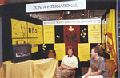
Zonta Stand

